NAME: Jamal Mohideen
REG-NO: 192421028
EXPERIEMNT – 31
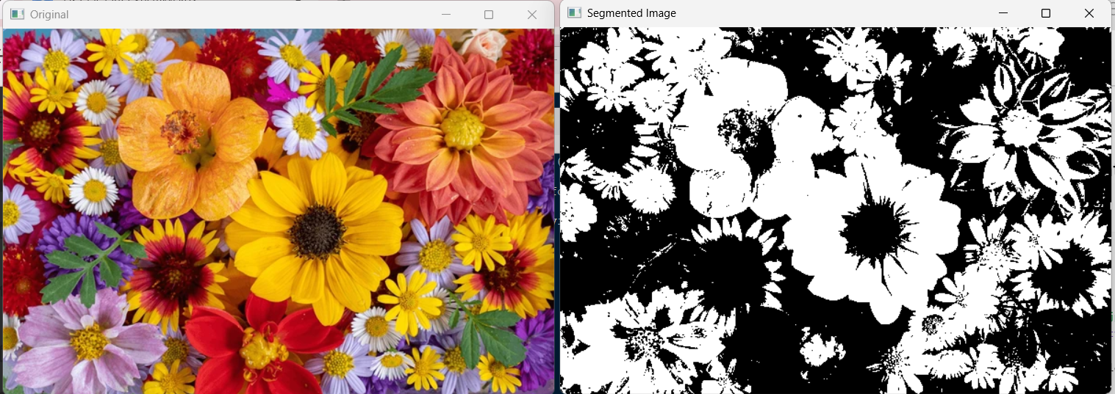
EXPERIMENT – 32
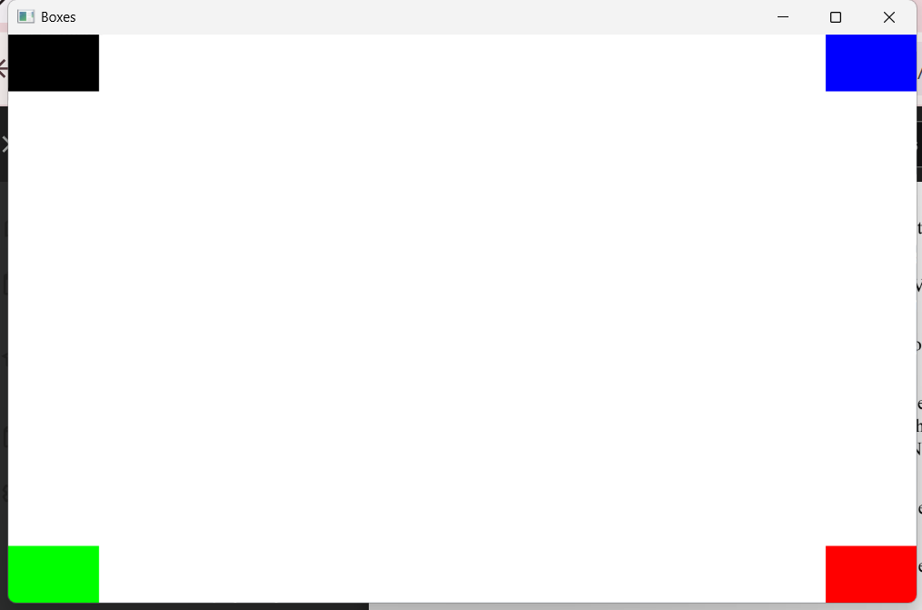
EXPERIMENT – 33
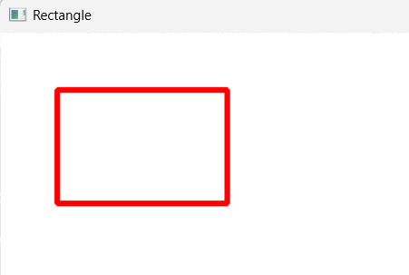

EXPERIMENT – 34

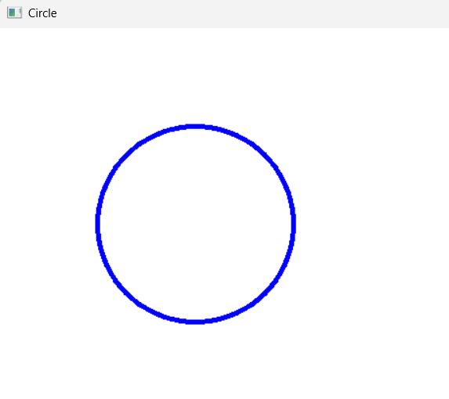
EXPERIEMNT – 36
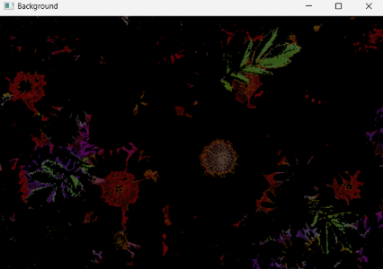
EXPERIMENT – 37
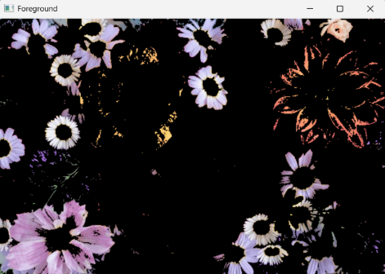

EXPERIMENT – 38

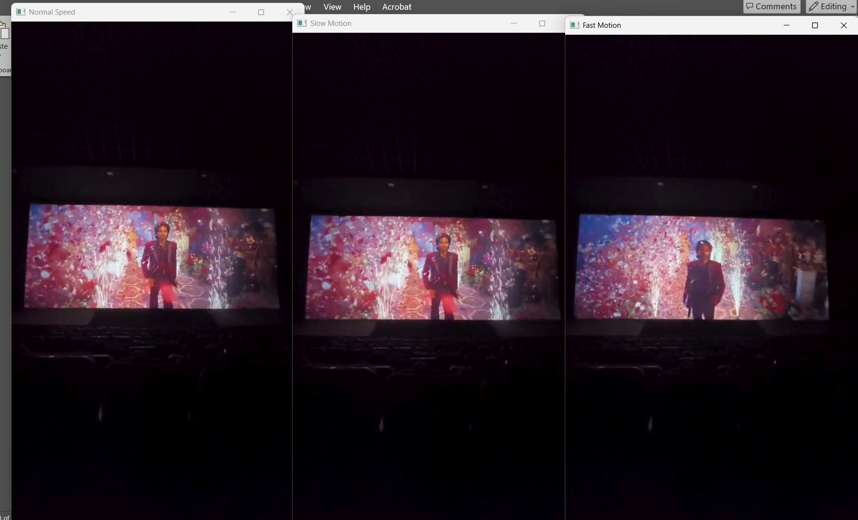

EXPERIMENT – 39
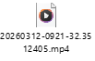

EXPERIMENT – 40



